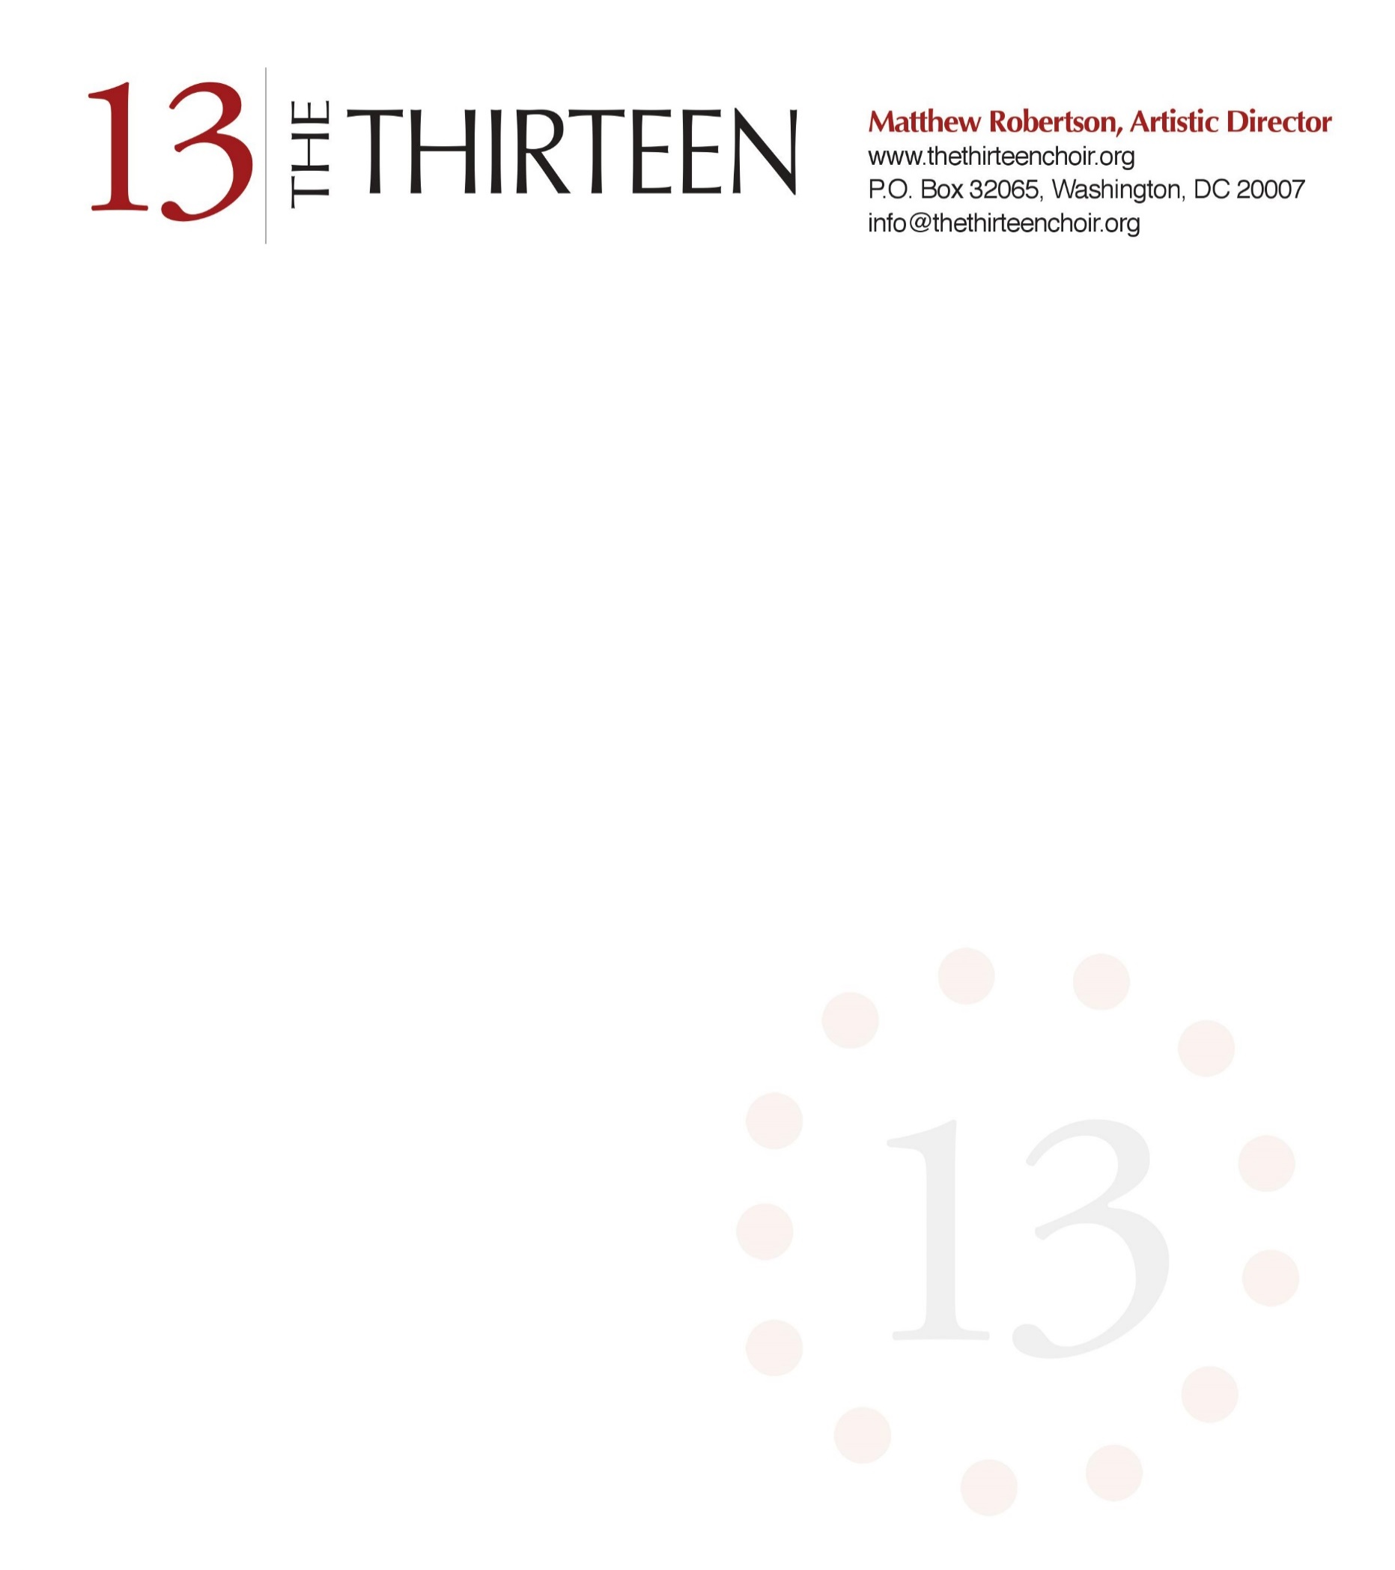

The Thirteen Calls Washington “Home” and Adds Cultural Icons to Board of Directors

May 16, 2016…Washington, D. C., The Thirteen announced major changes to the young, critically acclaimed all-star professional choir with move of its administrative headquarters to Washington, D. C., and the addition of major, internationally known cultural experts to its roster of Board members.
Matthew Robertson, a Washington native, is Founder and Artistic Director of the Choir, and announced the decision to return to Washington, to enrich this already-vibrant cultural environment. Robertson received a degree in Organ Performance, as the Fountain Scholar, at the Oberlin Conservatory in 2010. He went on to earn a Master’s of Music Degree in Conducting from the Westminster Choir College in 2012 where he served as Assistant Conductor of the famed Westminster Symphonic Choir. Robertson graduated from Walt Whitman High School in Bethesda, Maryland. Mr. Robertson is also Director of Music at Bradley Hills Presbyterian Church, Bethesda, Maryland.
Robertson has conducted The Thirteen throughout the United States and on multiple recordings. Garnering praise from critics, The American Record Guide describes the Choir as having a “light and attractive vocal blend and excellent choral discipline.” The Choir has performed residencies at major universities and performed concerts throughout the country. With a passion for educating new audiences, the Choir also routinely coaches generations of musicians in high schools and colleges through masterclasses and workshops.
The Choir recently acquired the talent of cultural and business icons to serve on the Board. Soprano Phyllis Bryn-Julson, Chair of Voice, Peabody Conservatory of Music, is considered one of the finest interpreters of the vocal music literature in the world. She has appeared with every major European and North American orchestra under leading conductors. She has 100 recordings to her credit and been nominated twice for Grammy Awards. The remarkable career of Ms. Bryn-Julson includes numerous awards such as: The Paul Hume Award and the Catherine Filene Shouse Award.
Charles Cerf, singer and arts advocate, has lived in Washington with his family for many years where he is a prominent fixture in the choral community. Mr. Cerf currently serves on the Board of Trustees of the Choral Arts Society of Washington, with which he has sung for many years, and the American Civil Liberties Union. Previously, he has sung with the prominent Harvard Glee Club and the Handel and Haydn Society.
World-renown organist, Donald Sutherland, is Coordinator of Organ at The Peabody Conservatory of Music where he was given the Excellence in Teaching Award by the Johns Hopkins Alumni Association in 1997. Mr. Sutherland appeared frequently in recital around the world; and was one of two American performers at the first Soviet–American International Organ Festival in Aachen, Germany.
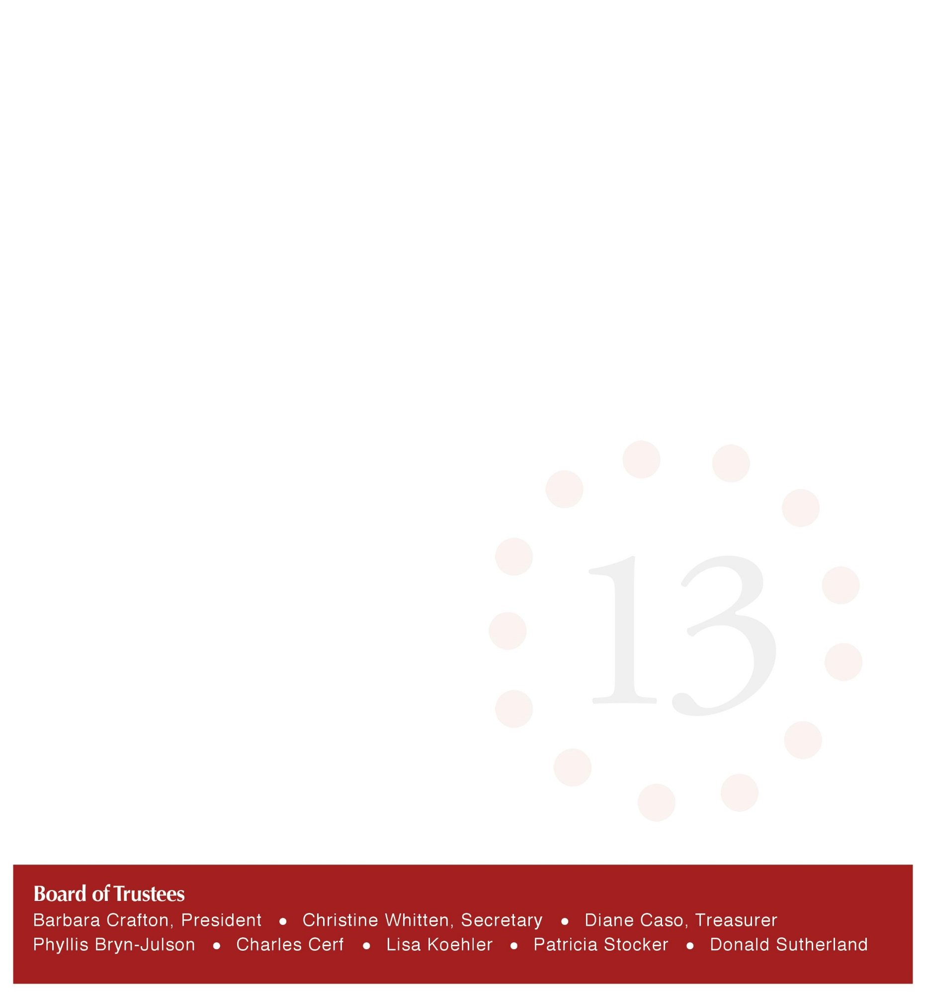
Singer Source founder and owner, and native Washingtonian, Lisa Koehler, brings extensive experience as a singer where she received a Master of Music in Music Education from the Catholic University of America. She has sung with numerous choral groups including the Choral Arts Society of Washington and the Cathedral Choral Society. Ms. Koehler launched Singer Source in 2004 to fill a void in support of choral groups with the best voice, skill and personality to complement the group. She also served as Co-Chair the Advisory Council on Instruction of the Arts, Arlington County, Virginia Public Schools.
Noted educator and business woman, Pat Stocker, Ph.D., brings business acumen to the Board as well as an appreciation of music and the arts. She is Program Director of the Leadership Council on Advancing Women for the prestigious Conference Board. She is an Executive Consultant for Marriott International. Dr. Stocker has served on the boards of Suburban Hospital in Bethesda, MD, and the American Association of University Women.
With Washington as the new home for The Thirteen, the 2016-17 season promises to be an exciting year for lovers of choral music. For additional information on the Choir go to: www.TheThirteenChoir.org.

Information Contact:
Christine Whitten
203.535.1908
info@thethirteenchamberchoir.com

###

